The Conditions of
The Testimony of Faith

by:
Jamaal Zarabozo

1428هـ - 2007م

شروط الشهادة
(باللغة الإنجليزية)

تأليف
جمال زرابوزو

تعديل
المكتب التعاوني للدعوة وتوعية الجاليات بالربوة

مراجعة
معيد عبد السلام أبو هشام
عبد الرحمن مراد – أحمد بولتر

1428هـ - 2007م

First Edition, 1428/2007
©2006, Jamaal Zarabozo.
Permission is granted to all to take material from this publication, subject to the following three conditions: 1) It may not be used for profit-able ventures; 2) Material must be source to the copyright owner; 3) Material must not be taken out of context.
We would like to express our sincere appreciation to those who contributed to the publication of this book. May Allah reward them for their efforts. If you have any corrections, comments, or questions about this publication, please feel free to contact us at:
en@islamhouse.com

1428 H
[ 3015 ]

Published by:
The Islamic Propagation Office in Rabwah
Tel. +4454900 - 4916065
Email: en@islamhouse.com

www.islamhouse.com

Contents

The Conditions of the Shahaadah 5
-Knowledge 7
-Certainty 9
-Acceptance 11
-Submission and Compliance 13
-Truthfulness 15
-Pure Sincerity 17
-Love 19
-Denial of all other Deities 21
-Adherence until Death 23
“And that Muhammad is the Messenger of Allah” 24
-The Chosen Prophet 25
-A Prophet for All Times and Places 27
-Perfect Preaching 29
The Obligations of the Shahaadah 32
-Love 32
-A Model Example 33
Ruling Concerning One who Violates the Shahaadah 36
z
The Conditions of ‘La ilaaha ill-Allah’

Muslims know that the key to Paradise is the statement, “There is none worthy of worship except Allah.” Yet many Muslims simply rely upon this statement and believe that as long as they have said it, nothing will harm them. Because of this mere verbal statement of the shahaadah, they think they will be granted Paradise. However, the mere saying of the statement is not sufficient for salvation. In fact, the hypocrites used to say, “I testify that none is worthy of worship except Allah and…” yet Allah describes them as liars and says that they shall abide in the lowest abyss of the Hellfire.
As many scholars have stated, this statement, or testimony, is the key to Paradise. However, its saying must meet certain conditions. Al-Hasan al-Basri once told a person,
“What have you prepared for death?” He replied, “The testimony that there is none worthy of worship except Allah.” Al-Hasan told him, “That has some conditions to it. And beware of defaming chaste women.”
The famous Follower Wahb ibn Munabbih was once asked,
“Isn’t the statement of la ilaha illa-llah the key to Paradise?” He answered, “Yes, but every key has ridges. If you come with the key that has the right ridges, the door will open for you. Yet if you do not have the right ridges, the door will not open for you.”
These ridges are conditions that differentiate Muslims who will benefit from that statement from those who will not benefit from that statement, no matter how many times a day they may have made that statement.
Before discussing the conditions of the shahaadah, there is one more point that should be made. Some people have a tendency to take one hadith or one verse and then, based on that one text, make a general conclusion solely based on that one text. For example, one could conclude from some hadith that whoever simply says, “There is no God except Allah,” will enter Paradise. But, actually, one must realize that all of the Quran and hadith complement each other and explain one another. To find the correct position on any one question, one must bring together all of the related verses and hadith and see what the true Islamic position is on that question. The same is true for the conditions of the shahaadah.
A study of the verses of the Quran and the hadith of the Prophet () will show that the conditions of the shahaadah are seven, eight or nine in number depending on how one views them. It is important that every Muslim ensures that he is meeting these conditions in his own life with respect to his own testimony of faith.
Knowledge

The first condition is knowledge: One must have the necessary basic understanding of what is meant by the shahaadah. One must understand what the shahaadah is affirming and what the shahaadah is denying. Allah says in the Quran,
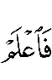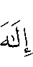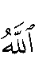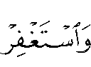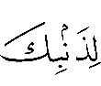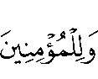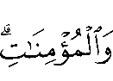
“So know that there is no God save Allah, and ask for-giveness for your sin and for the believing men and the believing women” (Muhammad 19).
Similarly, the Prophet () said,
« مَنْ مَاتَ وَهُوَ يَعْلَمُ أَنَّهُ لا إِلَهَ إِلاَّ اللَّهُ دَخَلَ الْجَنَّة »
“Whoever dies knowing that there is no one worthy of worship except Allah shall enter Paradise.” (Recorded by Muslim.)
In fact, the shahaadah itself is a testimony. When one testifies to something, one must know what it is that he is testifying concerning. Obviously, a testimony about something that one does not have any knowledge of is unacceptable. Allah says in the Quran,
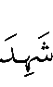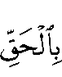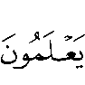
“Save him who bears witness unto the truth knowingly” (al-Zukhruf 86).
Therefore, the basics of the shahaadah must be understood by the person testifying to it. If he does not understand, for example, that Allah is the only one worthy of worship and that all other gods are false gods, then he does not even have the most elementary understanding of what it is he claims to be testifying to. Such a shahaadah cannot be considered a proper one that is acceptable to Allah.
Certainty

The second condition of the shahaadah is certainty or al-yaqeen. This is the opposite of doubt and uncertainty. In Islam, in fact, any kind of doubt concerning anything confirmed in the Quran or the sunnah is equivalent to kufr or disbelief. One must, in his heart, be absolutely certain of the truth of the shahaadah. One’s heart must not be wavering in any way when one testifies to the truth of, “There is none worthy of worship except Allah.” Allah describes the true believers as those who have belief in Allah and then their hearts waver not. Allah says,
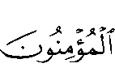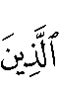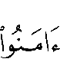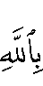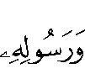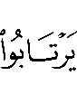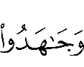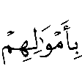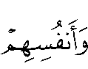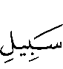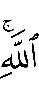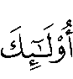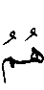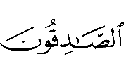
“The (true) believers are only those who believe in Allah and His messenger and afterward doubt not, but strive with their wealth and their lives for the cause of Allah. Such are the sincere” (al-Hujuraat 15).
Similarly, the Messenger of Allah () said,
« أَشْهَدُ أَنْ لا إِلَهَ إِلاَّ اللَّهُ وَأَنِّي رَسُولُ اللَّهِ لا يَلْقَى اللَّهَ بِهِمَا عَبْدٌ غَيْرَ شَاكٍّ فِيهِمَا إِلاَّ دَخَلَ الْجَنَّةَ »
“No one meets Allah with the testimony that there is none worthy of worship but Allah and I am the Messenger of Allah, and he has no doubt about that statement, except that he will enter Paradise.” (Recorded by Muslim.)
On the other hand, Allah describes the hypocrites as those people whose hearts are wavering. For example, Allah says,
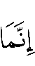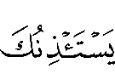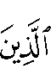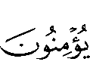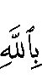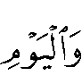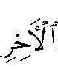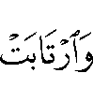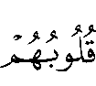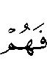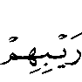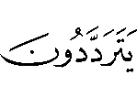
“They alone seek leave of you [not to participate in jihad] who believe not in Allah and the Last Day and whose hearts feel doubt, so in their doubt they waver” (al-Tauba 45).
Many scholars have stated that the diseases of the heart, or the doubts and suspicions that one allows into one’s heart, are more dangerous for a person’s faith than lusts and desires. This is because lusts and desires may be satisfied at some time yet the person still knows them to be wrong. He may then eventually be able to control himself, repent and give up those evil deeds. On the other hand, doubts and suspicions may linger in the heart, with no cure, until the person finally leaves Islam entirely or continues to practice Islam while, in fact, in his heart he does not have the true faith.
One of the greatest cures for these doubts is knowledge. A sound knowledge of the Quran and sunnah removes most, or all, of these doubts. By study and understanding, one may attain certainty. And as one studies and learns more, his certainty will be made firmer and firmer.
Acceptance

The third condition of the shahaadah is acceptance or al-qabool. If a person has the knowledge of and certainty in the shahaadah, this must be followed by acceptance, with the tongue and heart, of whatever that shahaadah implies. Whoever refuses to accept the shahaadah and its implications, even if he knows that it is true and is certain about its truth, is a disbeliever. This refusal to accept is sometimes due to pride, envy or other reasons. In any case, the shahaadah is not a true shahaadah without its unconditional acceptance.
The scholars talk about this condition as a general condition in the manner just described. However, there is also a more detailed aspect that one must be aware of. This condition also means that he believes in whatever is stated in the Quran or stated by the Prophet (), without any right to choose what he wants to believe and what he wants to reject. Allah says in the Quran,
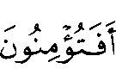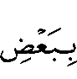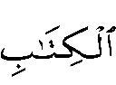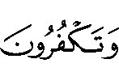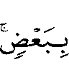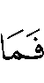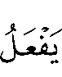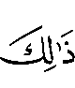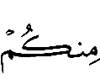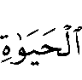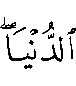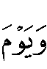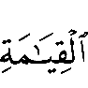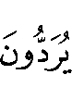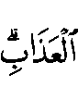
“Do you believe in part of the Book and reject part of it? And what is the reward of those who do so save ignominy in the life of the world, and on the Day of Resurrection they will be consigned to the most grievous doom” (al-Baqara 85).
Allah has also said,
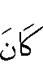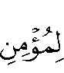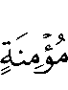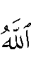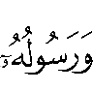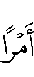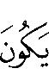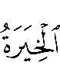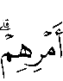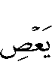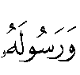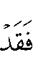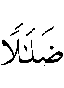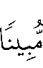
“It is not for a believing man or believing woman, when Allah and His Messenger have decreed a matter, to have any option in their decision. And whoever disobeys Allah and is Messenger has indeed strayed in plain error” (al-Ahzaab 36).
Submission and Compliance

The fourth condition of the shahaadah is submission and compliance or al-inqiyaad. This implies the actual physical enactment by deeds of one’s shahaadah. This is one of the main meanings of the word Islam itself, “the submission to the will and commands of Allah.” Allah commands this in the Quran,
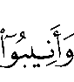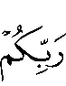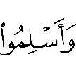
“Turn unto Him repentant, and surrender unto Him” (al-Zumar 54).
Allah has praised those who submit to His command by their actions. Allah says,
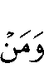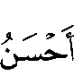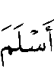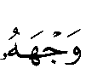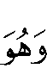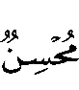
“Who is better in religion than he who surrenders his purpose to Allah while doing good” (al-Nisaa 125).
Allah has made it a condition of faith that one submits to the command of Allah and His messenger. Allah says,
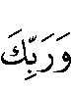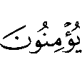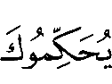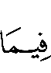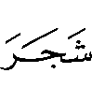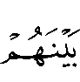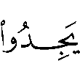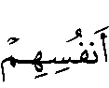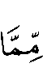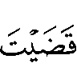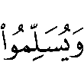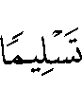
“But nay, by your Lord, they will not truly believe until they make you [the Messenger of Allah] judge of what is in dispute between them and find within themselves no dislike of that which you decide, and submit with full submission” (al-Nisa 65).
As shall be discussed in the discussion on Imaan, the shahaadah is a testimony of faith that must be implemented in one’s heart, tongue and actions. In one’s heart, for example, one must have love for Allah, fear of Allah and hope in Him. With one’s tongue, one must testify to the shahaadah. With one’s actions, one is supposed to implement what the testimony of faith requires of him. Anyone who claims to be a Muslim and yet performs no corresponding acts, either does not understand Islam whatsoever or is bearing testimony against himself that his testimony of faith is not a true and correct testimony of faith.
This does not mean that the true believer never falls into sin. Indeed, true believers do commit sins. But as long as they recognize that what they did is not correct and it is inconsistent with their obligation of submitting to Allah, then they have not violated the soundness of their testimony or shahaadah.
Truthfulness

The fifth condition is truthfulness as opposed to hypocrisy and dishonesty. This means that when one says the shahaadah, he is saying it honestly, actually meaning it. He is not lying when it comes to his testimony of faith or simply trying to deceive or fool anyone. The Prophet () said,
« مَا مِنْ أَحَدٍ يَشْهَدُ أَنْ لا إِلَهَ إِلاَّ اللَّهُ وَأَنَّ مُحَمَّدًا رَسُولُ اللَّهِ صِدْقًا مِنْ قَلْبِهِ إِلاَّ حَرَّمَهُ اللَّهُ عَلَى النَّار »
“No one bears testimony to there being no one worthy of worship save Allah, sincerely from his heart, except that Allah makes the Hell-fire forbidden for him.” (Recorded by al-Bukhari.)
Most people have heard of those who say the testimony of faith yet they are not saying it honestly. They do not believe in it. They are simply saying it in order to protect themselves or to get some gain from doing so. These are the hypocrites. Allah has described them in the opening of the Quran with the following words,
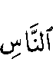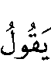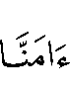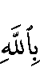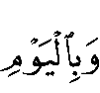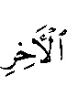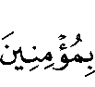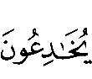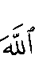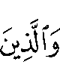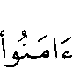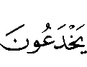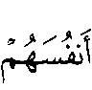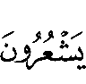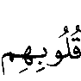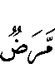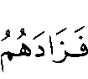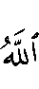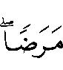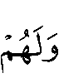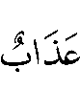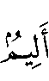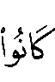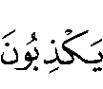
“And of mankind are some who say, ‘We believe in Allah and the Last Day,’ when they believe not. They think to beguile Allah and those who believe, and they beguile none save themselves, but they perceive not. In their hearts is a disease, and Allah increases their disease. A painful doom is theirs because they lie” (al-Baqara 8-10).
The shahaadah of those who become Muslims only to benefit from being Muslim and not because they believe in Islam will be rejected by Allah in the Hereafter. They will face a painful punishment due to their lying.
Pure Sincerity

The sixth condition is pure sincerity or ikhlaas. When one declares the shahaadah, one must do that solely for the sake of Allah. One must not do it for any other reason or anyone else’s sake. In this manner, the meaning of purity is the opposite of shirk, or ascribing partners with Allah. One becomes and remains Muslim solely to serve Allah, to avoid His anger and punishment and to gain His mercy and reward. Allah says in the Quran,
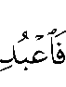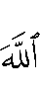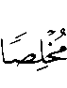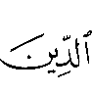
“Worship Allah, making religion pure for him” (al-Zumar 2).
Allah also says,
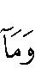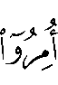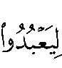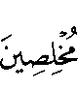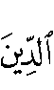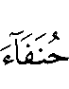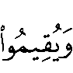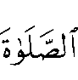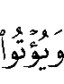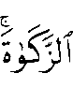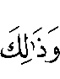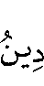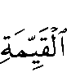
“And they are ordered not else than to serve Allah, keeping religion pure for Him, as men by nature upright and to establish worship and to pay the poor-due. That is the true religion” (al-Bayyinah 5).
The Prophet () also said,
« إِنَّ اللَّهَ قَدْ حَرَّمَ عَلَى النَّارِ مَنْ قَالَ لا إِلَهَ إِلاَّ اللَّهُ يَبْتَغِي بِذَلِكَ وَجْهَ اللهِ »
“Allah has forbidden for the Hell-fire anyone who says, ‘There is no one worthy of worship except Allah,’ and says so desiring the face [and pleasure] of Allah.” (Recorded by Muslim.)
This is something that all Muslims should think about, but especially those who grew up in Muslim families and were born Muslim. Everyone should be clear to himself that he is Muslim only for the sake of Allah. A Muslim cannot be a Muslim for the sake of his parents, friends, family, community or worldly goal. It must be clear in the mind that one is a Muslim for the sake of Allah first, last and only.
Love

The seventh condition is love. That is, the believer loves this shahaadah, he loves in accordance with the shahaadah, he loves the implications and requirements of the shahaadah and he loves those who act and strive on the basis of this shahaadah. This is a necessary condition of the shahaadah. If a person makes the shahaadah but does not love the shahaadah and what it stands for, then, in fact, his faith is not complete. It is not the faith of a true believer. If he has no love for this shahaadah or if he actually feels hatred for it, he has negated his shahaadah.
The true believer puts no one as an equal to Allah in his love. Allah says in the Quran,
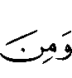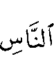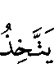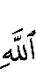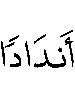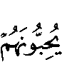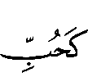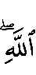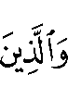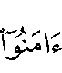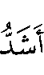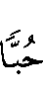
“Yet of mankind are some who take unto themselves (objects of worship which they set as) rivals to Allah, loving them with a love like (that which is due to) Allah only. However, those who believe are stauncher in their love of Allah” (al-Baqara 165).
Elsewhere Allah says,
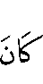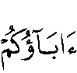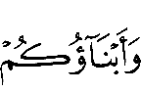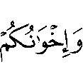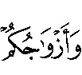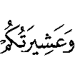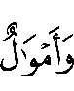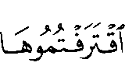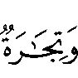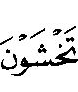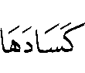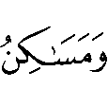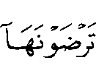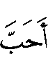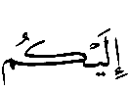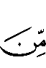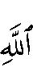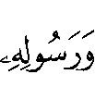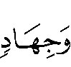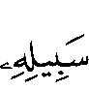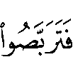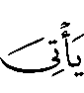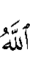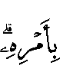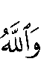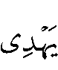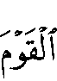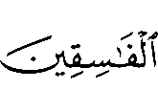
“Say: If your fathers, your sons, your brethren, your wives, your tribe, the wealth you have acquired, merchandise for which you fear that there will be no sale, or dwellings you desire are dearer to you than Allah and His messenger and striving in His way: then wait till Allah brings His command to pass. Allah guides not wrongdoing folk” (al-Tauba 24).
The Prophet () said,
« ثَلاثٌ مَنْ كُنَّ فِيهِ وَجَدَ حَلاوَةَ الْإِيمَانِ أَنْ يَكُونَ اللَّهُ وَرَسُولُهُ أَحَبَّ إِلَيْهِ مِمَّا سِوَاهُمَا »
“Whoever has three characteristics has tasted the sweetness of faith. [The first of these] is that he loves Allah and His Messenger more than he loves anyone else...” (Recorded by al-Bukhari and Muslim.)
Denial of all other Deities

An eighth condition of the shahaadah is that the person who makes the shahaadah must deny every other object of worship. Although that is clear in the words of the testimony of faith, it does not seem clear to everyone who makes that testimony. Therefore, it needs to be mentioned explicitly.
In surah al-Baqara, Allah reminds Muslims of this important aspect of the shahaadah. The shahaadah is not merely an affirmation but it is both an affirmation and a negation. Allah states,
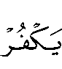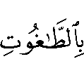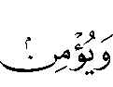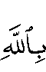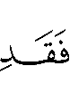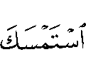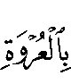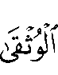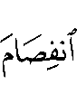
“And he who rejects false deities and believes in Allah has grasped a firm handhold which will never break” (al-Baqara 256).
The Prophet () emphasized this point when he said,
« مَنْ قَالَ لا إِلَهَ إِلاَّ اللَّهُ وَكَفَرَ بِمَا يُعْبَدُ مِنْ دُونِ اللَّهِ حَرُمَ مَالُهُ وَدَمُهُ وَحِسَابُهُ عَلَى اللهِ »
“Whoever says there is no one worthy of worship except Allah and denies whatever is worshipped besides Allah, then his wealth and blood are protected and his account-ing will be with Allah.” (Recorded by Muslim.)
Although this condition should be obvious to everyone who says the words of the shahaadah, one can still find Muslims who say the shahaadah and then make acts of worship for beings or things other than Allah. One can find them going to the graveyards and worshipping those in the graves. They will perform acts of worship, not for the sake of Allah, but for the sake of the dead “saints” (auliyaa) in the grave.
Adherence until Death

The ninth condition of the shahaadah is that the Muslim adheres to the shahaadah until he dies. This is a must if the shahaadah is to mean anything in the Hereafter. One cannot rest on his laurels of what he may have done in the past. No indeed, the shahaadah must be his banner until death. Allah says in the Quran,
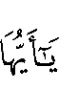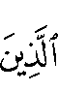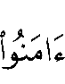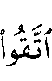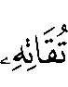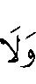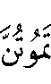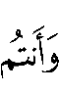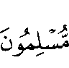
“O believers, observe your duty to Allah with right observance, and die not save as Muslims [surrendering your-selves to Allah]” (Ali-Imraan 102).

“And that Muhammad is the Messenger of Allah”

Most everyone knows that to enter into Islam one must bear witness that there is none worthy of worship save Allah and that Muhammad is the Messenger of Allah (). Many times the first part of the shahaadah or testimony is discussed in detail. However, it is just as important to understand the meaning and the implications of the second part of the shahaadah. Indeed, sometimes one strays from the Straight Path and from Islam itself because he is not implementing the second part of the shahaadah properly.
The Chosen Prophet

When one testifies that Muhammad is the Messenger of Allah, he is stating his belief that the Prophet Muhammad () was chosen by Allah to be His Messenger and to convey His Message. Allah says in the Quran,
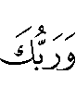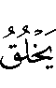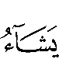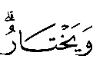
“And your Lord creates whatsoever He wills and He chooses” (al-Qasas 68).
Allah creates and has power to do all things. Allah specifically chose the Prophet Muhammad () to be His Messenger. In another verse, Allah says,
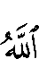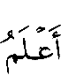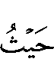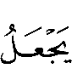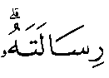
“Allah knows best with whom to place His Message” (al-Anaam 124).
This implies some characteristics of the Prophet Muhammad () as obviously Allah, due to His justice, wisdom and mercy, would not choose one who is treacherous or lying to be His Messenger. Allah would not choose anyone for such an important mission whom He knew would not convey the message or who would use the position to his own advantage. If anyone claims that the Prophet () did not actually convey the entire message or that he distorted it in any way, he is actually saying that Allah did not know who was the correct or best person to be a messenger. This is obvious disbelief.
A Prophet for All Times and Places

Second, when one makes the shahaadah, he is also testifying that the Prophet () has been sent for all of mankind until the Day of Judgment. Allah says in the Quran,
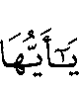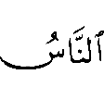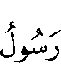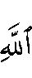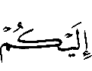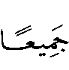
“Say [O Muhammad]: O mankind! Verily, I am sent to you all as the Messenger of Allah” (al-Araaf 158).
Furthermore, the Prophet () said,
« أُعْطِيتُ خَمْسًا لَمْ يُعْطَهُنَّ أَحَدٌ مِنَ الْأَنْبِيَاءِ قَبْلِي… وَكَانَ النَّبِيُّ يُبْعَثُ إِلَى قَوْمِهِ خَاصَّةً وَبُعِثْتُ إِلَى النَّاسِ كَافَّةً »
“I have been given five aspects that were not given to any prophet before me... [One of which is] every prophet was sent only to his people while I have been sent to all of mankind.” (Recorded by al-Bukhari and Muslim.)
It is obligatory upon everyone from the time of the Prophet () until the Day of Judgment to believe in and follow the Prophet (). If the message of Islam clearly reaches a person and he still refuses to believe in and follow the Prophet (), he is a disbeliever and will be in the Hell-fire forever — unless he repents and embraces Islam.
However, this also implies that the Prophet’s teachings and his sunnah are valid and obligatory upon all of mankind until the Day of Judgment. That is, his example and teaching was not simply for the people of Arabia at his time. Instead, it is just as valid and just as important for each and every Muslim today, whether he be in New York or Malaysia.
Some people seem to try to resist the idea that they have to follow the Prophet (). When they do so, they must realize that they are going against what they have testified to. They have testified that the Prophet’s message, which includes both the Quran and his inspired sunnah, is for all of mankind — including each and everyone alive today.
Perfect Preaching

Third, when one declares the shahaadah, he is testifying that he believes with certainty that the Prophet Muhammad () conveyed the message — he conveyed it correctly, he conveyed all of it, and he conveyed it clearly. Allah says in the Quran,
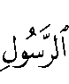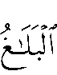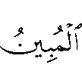
“The Messenger’s duty is only to convey (the message) in a clear way” (al-Noor 54).
The Prophet () himself said,
« قَدْ تَرَكْتُكُمْ عَلَى الْبَيْضَاءِ لَيْلُهَا كَنَهَارِهَا لاَ يَزِيغُ عَنْهَا بَعْدِي إِلاَّ هَالِكٌ »
“I left you on a bright path whose night and day are alike. No one strays from it after me except he is destroyed.” (Ibn Maajah)
The Prophet () conveyed all of the guidance and revelation that he received from Allah. He conveyed and explained it in a clear manner. Therefore, when one makes the shahaadah, he is also testifying that the Prophet () conveyed all the aspects of the religion – its fundamental as well as its secondary aspects. There is no part of the religion that one needs for his guidance that was not conveyed to mankind or that Allah or the Prophet () may have possibly forgotten.
Therefore, when this complete and clear guidance from the Prophet () is present, there is no need for any Muslim to turn to other sources for guidance. There is no need for one to turn to the books of the Jews or Christians. Indeed, the Prophet () told Umar, when he saw him reading the Torah, that if the Prophet Moses were alive at his time, he would also have to follow the Prophet Muhammad (). There is no need for any Muslim to turn to the Greek philosophers, for example, to learn about theology. In fact, there is no need for Muslims to turn the religious or spiritual teachings of any non-Muslims to get guidance. All that is needed is to be found in the Quran and sunnah. This is part of what the Muslim is testifying to. The Muslim bears witness that the Prophet () conveyed the entire message. This is all part of the meaning of the sha-haadah.
When one declares, “Muhammad is the Messenger of Allah,” one is also declaring that he is the final prophet sent by Allah. Allah says in the Quran,
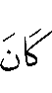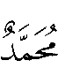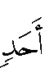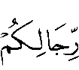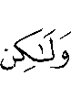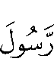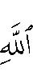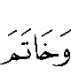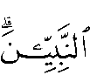
“Muhammad is not the father of any man among you, but he is the Messenger of Allah and the Last of the Prophets” (al-Ahzaab 40).
There is to be no prophet who is going to come after the time of the Prophet Muhammad (). No new prophet and no new scripture will come that will abrogate what the Prophet Muhammad () brought. Furthermore, if anyone after the time of the Prophet Muhammad () claims to be a prophet, it is known automatically that such a person is a liar and a deceiver. He must be opposed and it should be declared to all that his claim to prophethood is false. To accept anyone as a prophet after the Prophet Muhammad () is to falsify one’s declaration of the shahaadah.
The Obligations of the Shahaadah

When one makes the testimony of faith or the shahaadah, this not only implies that he believes in certain things but it also implies that he accepts certain responsibilities that stem from that shahaadah. For example, when he says that there is none worthy of worship except Allah, for that shahaadah to be a correct form of shahaadah, it means that he is now taking on the responsibility of worshipping no one other than Allah. Similarly, when one says, “I testify that Muhammad is the Messenger of Allah,” he is taking on certain responsibilities with respect to the Prophet Muhammad (). When he is lacking in any of these responsibilities, then he is lacking in his complete fulfillment of his testimony of faith. It can even get to the point that he negates his shahaadah completely by refusing to fulfill his responsibility to the Prophet Muhammad ().

Love
One of these obligations toward the Prophet () is to love him. This does not just imply any form of love, but that complete Imaan requires that one loves the Prophet () more than anyone or anything else of this world. Allah says in the Quran,
“Say: If your fathers, your sons, your brothers, your wives, your kindred, the wealth that you have gained, the com-merce in which you fear a decline, and the dwellings in which you delight are dearer to you than Allah and His Messenger, and striving hard and fighting in His cause, then wait until Allah brings about His Decision (torment). And Allah guides not the people who are disobedient” (al-Tauba 24).

A Model Example
Second, when one makes the testimony of faith, this means that he is accepting the Prophet Muhammad () as his example of how to live and behave in a way that is correct and pleasing to Allah. Allah says in the Quran,
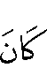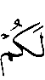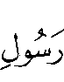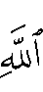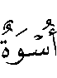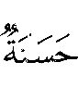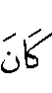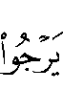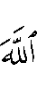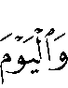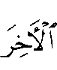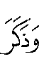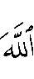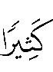
“Indeed in the Messenger of Allah you have an excellent example to follow for him who hopes in (a good meeting with) Allah and the Last Day and remembers Allah much” (al-Ahzaab 21).
Allah also says,
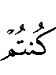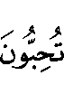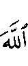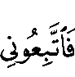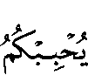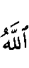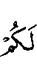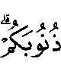
“Say (O Muhammad): If you love Allah, then follow me and Allah will love you and forgive you your sins” (Ali-Imraan 31)
It is very strange that some people can declare the testimony of faith and declare that Muhammad is the Messenger and Prophet of Allah – yet at the same time they do not consider him an example of the way of life that a believer should follow. Not only do they not take him as an example for themselves, they actually oppose others who do take the Prophet () as their example. This is nothing but a clear sign that such a person does not have a clear understanding of the meaning and implications of the testimony of faith that he made. The Prophet () has said,
« أَمَا وَاللَّهِ إِنِّي لَأَخْشَاكُمْ لِلَّهِ وَأَتْقَاكُمْ لَهُ لَكِنِّي أَصُومُ وَأُفْطِرُ وَأُصَلِّي وَأَرْقُدُ وَأَتَزَوَّجُ النِّسَاءَ فَمَنْ رَغِبَ عَنْ سُنَّتِي فَلَيْسَ مِنِّي »
“I swear by Allah that I am the most fearful of Allah and most conscious of Him than all of you. But I also [as part of my sunnah] fast and break my fast, pray and sleep [at night] and I marry women. Whoever turns away from my sunnah is not from me [that is, is not one of my true followers].” (Recorded by al-Bukhari.)
In this hadith, the Prophet () explained that he is the most fearful of Allah and God-conscious. Therefore, there is no excuse for anyone not to follow his example and guidance. But he also stated that the one who turns away from his practice and example is not from him. One cannot truthfully claim to believe in and accept the Prophet Muhammad () and, at the same time, refuse to accept his life as the example that one must strive to emulate.
Ruling Concerning One who Violates the Shahaadah

Anyone who knowingly and willingly violates the shahaadah becomes a disbeliever. There is agreement among all the scholars on this point. For example, if anyone worships anything or anybody else along with his worship of Allah, such as worshipping Jesus along with worshipping Allah, then that person becomes a disbeliever. Similarly, if anyone curses the Prophet () or claims that he was a liar, this person has violated the second portion of his testimony of faith and, thereby, falls outside of the fold of Islam.

Follower, or Taabi‘i in Arabic. Anyone who met one of the Sahaabah, or companions of the Prophet ().

